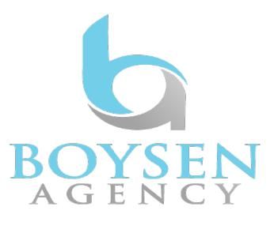
Tom Rieser

Non-Union

[height] | 5’7” | [agent]
[hair] | Brown | Michelle Hill
[eyes] | Hazel | 512-482-0040

[film]

Shadows at The Altar | Deacon Matthew | Dir: Regan Schenck/Gateway to Hell Studios
Premonition | Jake | Dir: Mahalia Butler / Axiom Productions
[commercial]

“K9 Minefields” ORA App Jason Dir: ORA App
“Don’t Settle For 5G” Pink Shirt Dad Dir: Willie Rockefeller/Originator Studios
[web]

If Nerf Fights Had Battle Royales Buddy Dir: Shiloh and Bros

Coffee-Parachuter (Music Video) | Jason | Dir: Anthony Najera /Colectivo Creative Media

Crazy Bills Gerald Dir: Jenny Fewell/Clumio
The Trouble With Snapshots Gerald Dir: Jenny Fewell/Clumio
Feel Me (Unofficial Music Video) Adorable Enterprise Guy Dir: Tristan Spohn/917 Media House
Project Outbreak: Uncertain Evening Male Dir: Gabby Mann/Pandemic Collective

[theatre]

Sherlock Holmes: P.O.T. | Einstein | Dir: Shauna Holloway/Rover Dramawerks
Spamalot | Patsy | Dir: Ken Ruffalo/West Aurora High School
Grease | Eugene | Dir: Aaron Henderson/Fox Valley Repertory
Little Shop of Horrors | Mr. Mushnik | Dir: Ken Ruffalo/West Aurora Auditorium
Phantom of the Opera | Chorus | Dir: Ken Ruffalo/West Aurora Auditorium
The Drowsy Chaperone | Chorus | Dir: Ken Ruffalo/West Aurora Auditorium

[training]

Bachelor of Arts Texas A&M University
Scene Intensive Class TBell Actors Studio/Suzanne Racz
The Sessions: Voice Acting in Video Games Sound Cadence Studios/Chris Rager
Bridge To the Booth Sound Cadence Studios/Wendy Powell
The Extra Mile Scene Study The Artists Playground/Glenn Morshower
Voice Acting and Performance Voices Carey/Bruce Carey
Classical Vocal Performance Rezel Voice Studio/Elizabeth Rezel
Anime ADR Jason Lord/Studio Topaz
Theatre Arts Texas A&M University/Amy Gue

[special skills]

Archery, Bowling, Billiards, Choir, English Accent, Frisbee, French Accent, Accent, German Accent, Guitar, Handgun, Hunting, Running, Russian Accent, Rifle, Karate, Piano, Scottish Accent, Southern Accent Swimming, Shotgun, Jump Rope, Roller Skating, Waltz (Basic)

